WaterSOLV™ Curative Topical Soil Applications
Agriculture

Background

The acidification of soil with topical applications of acid is a common practice in agriculture as growers observe the infiltration of water into soils become challenging more and more, year over year. By rule-of-thumb, 90%+ sulfuric acid is applied at rates of 65 gallons per acre during winter months as a means to open up the soil.

The practice of acidification is based on achieving an acidic pH target, usually ranging from 5.5 to 6.5 pH units. It is at these pH values that the bond between the anions and cations disassociate due to the presence of the acidity, and where the “complex of minerals” i.e. calcium and or magnesium carbonate, the calcium phosphate, as well as calcium-magnesium-ferric and sodium chloride break down from a scale, a crystal, to become soluble and available for plant uptake into the form of what we refer to as EC or TDS.

To realize optimum plant vitality, yields and product grade, it is important to look beyond the act of pH reduction, beyond what the acid does at time of use and onward to the fate of the acidic reaction. What we are doing to help fix the problem is providing temporary relief followed by increasingly detrimental results that are increasing operational costs and stifling crop vitality, yields and revenues. It’s critical to remember that pants are what they can drink and when they need to drink, it needs to be readily available and high-grade nutrition, not highly soluble sodium or zinc.

pH - Available Nutrition – Oxygen | Biology - Toxicity

Keeping the topic relevant to topical applications of acid to soils, the reasons soils become compromised is usually attributed to the formation of scale, where the EC, also known as TDS, the sum of cations and anions in water, evaporate to dryness and form scale. The reaction is no different than what we observe in our daily lives with hard water spots. Hard water spots don’t wash away with water or rain, and when we acidify them, we usually remove them. But in agriculture, when we acidify them, once the water is gone and they are not consumed, the differences however are significant in agriculture from three major perspectives;

- The nutrients we add are highly insoluble and can add to the formation of scale. The amount of scale is based on 4 to 6-acre feet of water, not just 1 drop of water. The ratio between 6 ft. of water and 1 drop is about 1,152: 1. So take that water spot, multiply it by 1,152, perhaps multiply that by 15 for the nutrient additives and that is about how much highly insoluble minerals, nutrition, we add to the soil on a seasonal basis. How do we make these minerals / nutrients available for our plant to drink? Lower the pH – basically dissolve the scale, minerals, nutrients into solution. Nutrients include metals and minerals;

Element | Ca | Mg | P | K | S | SO4 | Fe | Mn | Zn | Na | Cl | B | Cu | NO3 | Bac T
Solubility | 2 | 2 | 2 | 2 | 1 | 1 | 2 | 2 | 1 | 1 | 1 | 2 | 2 | 1
Nutrition Value | 3 | 3 | 3 | 3 | 3* | 3* | 3* | 3* | 3 | 4 | 4 | 4 | 3 | 3 | 4*
Characteristic | Nutrient &Scale |  |  |  | Nutrient &Food for bacteria |  |  |  | Tracer | Toxins |  |  |  | Energy Drink | Anoxic  Rot, Toxicity

Solubility: 1. Highly soluble - 2. Highly Insoluble
Nutritional Value: 3. Nutrient - 4. Toxin
* With bacteria usually a food source and propagates anaerobic bacteria, bio-films and toxic bio-wastes
Aerobic bacteria favorable, anaerobic bacteria highly detrimental

- Looking beyond the action during acidification, what happens when we consume the water and the acidified elements evaporate to dryness? You get scale, hard water spots. Even worse, these hard water spots will not dissolve with water, nor rain, nor D.O. water, R.O. Water, pure water, or much less your source water. These scales are even highly insoluble in acidified water. In turn we realized the availability of the nutrients for our plants to drink by acidification but once this event is allowed to evaporate to dryness, we formed more scale, more cementation, which is now NOT recoverable. Over time this builds up so bad that;

  - Our use of acid has substantially increased
  - Our infiltration continues to get worse
  - We observe a deficiency of cations in our tissue though there is plenty in the soil
  - We are prescribed drywall (gypsum) and more acid to try to get calcium into our vegetation
  - We revert to even more soluble forms of calcium that usually come with bad ingredients (sodium, sulfur, sulfate)
  - Our soils tend to become anoxic from over-watering, excess nitrogen, sulfur, sulfate and bacteria, while depleting levels of oxygen.

- Hindered soil infiltration leads to even worse conditions and higher operational costs. As we continue to do this our soils become insoluble, not possessing the ability to transport or retain much needed hydration, nutrition and oxygen for our plants to access on demand, especially in times of need like summer. These stresses diminish crops vitality, growth, yield and product grade. We observe this today with black layer, root rot, anaerobic soil profiles, the buildup of the cations in our soils namely Ca, Mg and K. We also find the most soluble mineral Na and metal Zn complexing in our soils and we have very little insight to what impact biofilms are having at restricting nutritional uptake and holding toxins in the watering zones. If we are concentrating elements like sodium and zinc in our soils, it’s likely we have infiltration issues from cementation and or biology films. If we find we have sufficient bacteria in our water and food source in our water and or soil, it is likely bacteria wastes and bio-films are playing a role – hindering infiltration, blocking nutritional flow, hydration and available oxygen.

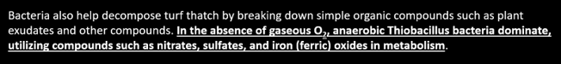

You will be shocked to see how your crops respond to available nutrition and oxygen.

Negative

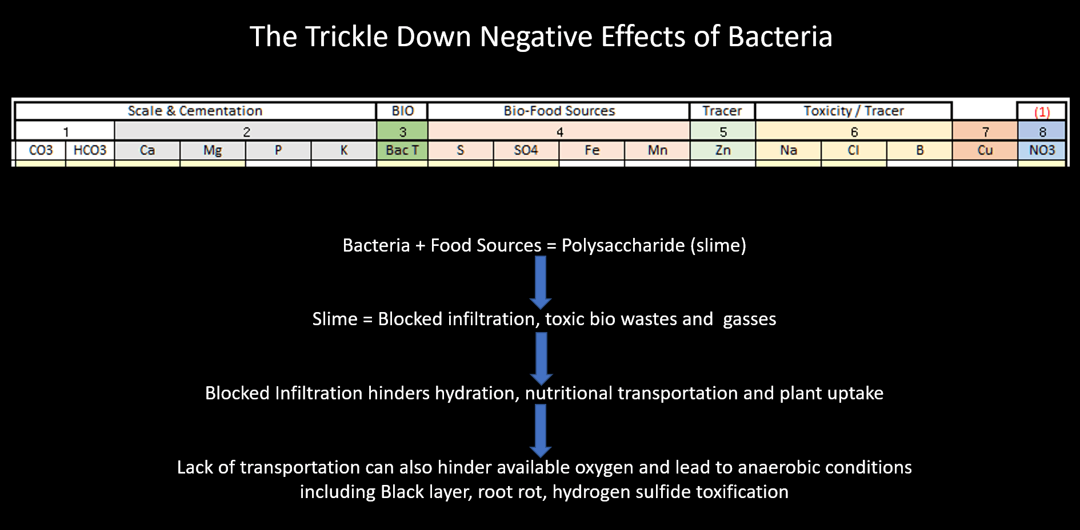

Positive

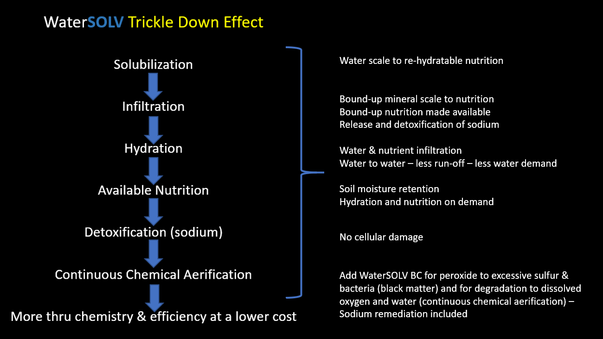

Summation:

- Minerals & nutrients have a tendency to form scale and build up over time to hinder vegetations access to hydration, nutrition and oxygen, stifling crop vitality, yield and product quality.
- Hindered infiltration leads towards anoxic and toxic conditions further hindering yields and increasing operational costs.
- Sulfurous acid is a temporary relief that is not sustainable due to the formation of insoluble salts and insoluble oxalates as evidence by standing water, the buildup of calcium in the soil profile, the saturation of elements in the soil including the soluble sodium and zinc, the addition of excess sulfur with bacteria, unwanted excess nitrogen and the need for gypsum to meet the crops tissue demands.

The WaterSOLV™ Difference

