7032 East Cortez Road
Scottsdale, AZ 85254
(888) 788-5807
info@hctllc.com
www.hctllc.com

Well-Klean® Solutions
Water Well Rehabilitation

WaterSOLV™
Making Water a Better Solution

Well-Klean®, WaterSOLV™ Water Treatment for Agronomy, WaterSOLV™ GROW & WaterSOLV™ pHix are tradenames of HCT, LLC

Select Solutions Registered with:
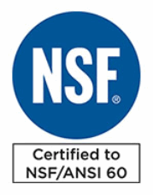
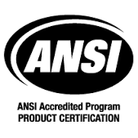
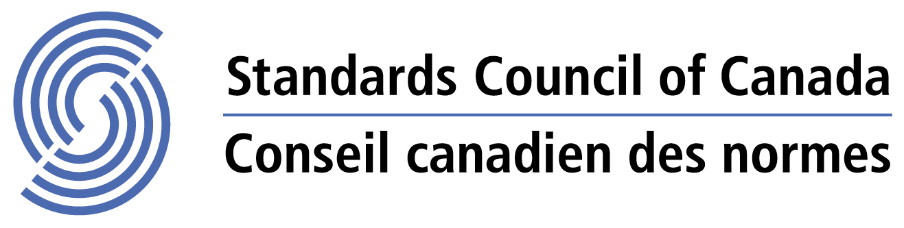

California Department of Food and Agriculture
December 28, 2020

Subject:

,

We’re in receipt of the following analyses relating to the above client regarding their conditions and what the WaterSOLV™ Program may be able to do for them. We have reviewed the data and make the following Observations, Interpretations and Recommendations (OIR’s).

☐ Water Analyses
☐ Water Bacteria Analysis
☐ Soil Analyses
☐ Soil Paste Extractions (Available from the soil by lab water)
☐ Exchangeable Cations (What’s all in the soil, but not available)
☐ Tissue Analyses

We ran the water and bacteria data through our mobile phone app to make the water treatment calculations. You can see that attachments hereto. Feel welcome to download the free app onto your cell phone – search HCT WaterSOLV™.

Soil data is extremely useful in making and demonstrating our overview, interpretations and recommendations. Showing the differences between Soil Paste Extractions and Ammonium Acetate Exchangeable Cations, when available, is a tell-all of soil saturations.

The WaterSOLV™ Program
Water, Soil, Tissue, Biology

We call it a program because so much is occurring with just one product, much less two, and other than modifying which products of the two to three, and the amount, the results/outcomes are always the same.

Water - As for the Mobile App Calculations; with the WaterSOLV™ Program, we only need to look at Ca, Mg, HCO3 for one aspect of the program (alkalinity exchange, pH suppression, cation conversion, sequestration) – then the Total Bacteria and Food Sources of the water, namely sulfur, sulfate, iron and manganese (bio control, slime control, continuous aerification by dissolved oxygen). Both these products mitigate the minerals, metals, biology, as well as the chloride challenges including bonds with sodium, calcium, iron and zinc. These mobile app parameters form the water treatment demand necessities leaving the soil remediation as a separate item.

Unique Water Variables to our Program - Two items can throw off the norms to our water treatment program; one being excessive Nitrate in the water or soil, and the other being excessive chloride and or sodium in water and or soil. Where NO3-N at concentrations over 20 ppm when acidized will block oxygen flow. Concentrations of Cl can be associated to bonds with Ca, Fe, Na, B and Zn and cause cell damage and tip burn.

Soil - Soil remediation/treatment is usually accomplished by increasing the water treatment volume for a period of time and also short and long-term watering practices including perhaps initial over-watering to get the treatment in the soil and then watering to water, versus watering to flush. We do NOT water to flush under the treatment program. Most users experiencing infiltration issues experience a water use demand reduction exceeding 10%.

Soil analysis is interesting as the reports can exhibit both available elements and then exchangeable elements. Very important to understand and know. The lab analysis, unless otherwise requested, may be the available or the exchangeable elements. Available is what they could release from the soil with lab water, usually deionized water. Exchangeable is what is actually what is in the soil in its totality, which is extracted using a solution of ammonium acetate. Your water, and or treated water with nutrition additives at times, will likely NOT produce the available elements depicted in the available analysis. The more exchangeable elements in the soil, usually indicates problems and likely more to follow as the “filter” become more saturated, hindering water absorption, infiltration and nutrient availability for the plant. Subsequently releasing the soluble toxins of Na and Cl while sustaining biology and bio-films.

Tissue – It is pretty clear plants are what they drink – the most toxic elements are more easily drank, the more beneficial elements are more difficult to drink, and nobody is dealing with the bio-films of the biology.

Here is what happens when we crate a sustainable environment in our soil which we accomplish with WaterSOLV™.

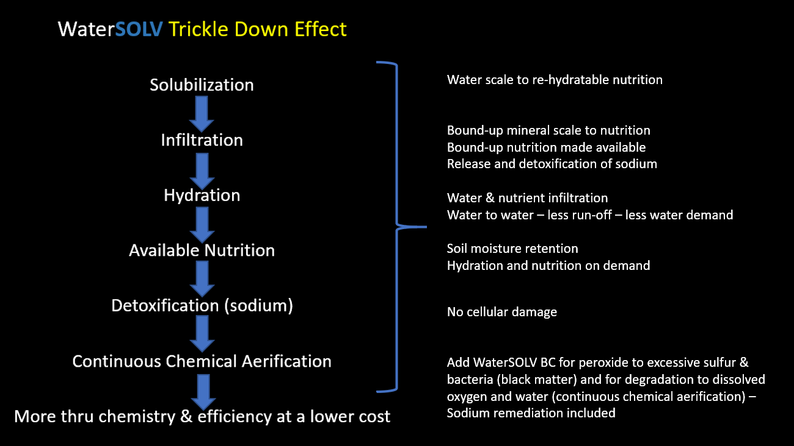

Biology - Here are the negative effects of biology and their slime and toxic gas production. Note, the BIO and BIO-Food Sources are the culprits, especially in soils compromised of bacteria, food sources, infiltration and oxygen.

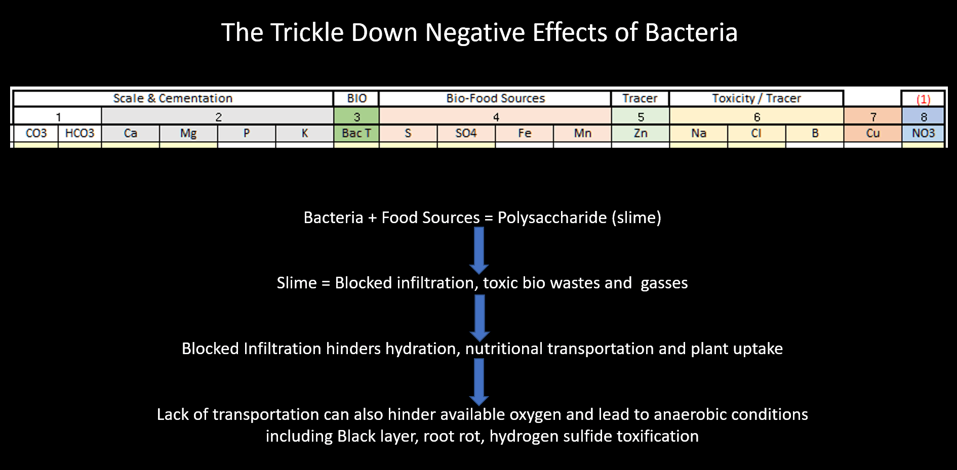
Figure 1 – Trickle Down Effect of bio and bio Food Sources.

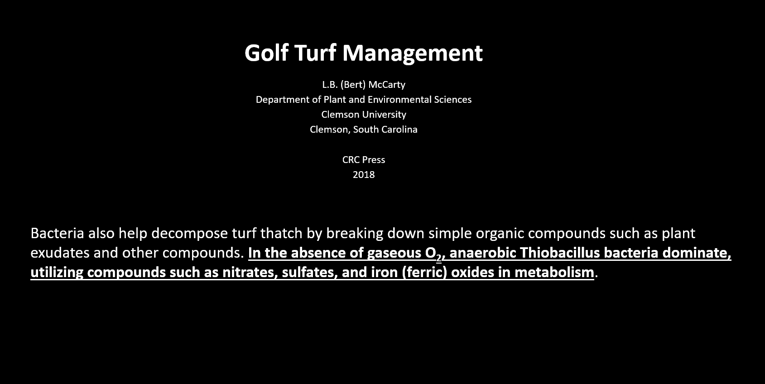
Figure 2 – Golf Turf Management Relating to Bacteria. Clemson University. It happens in soils everywhere.

About Water

As water with TDS/Ec evaporates the loss of water causes cations and anions to bound by either gas – bicarbonate and or chloride, or by valence (an energy attraction like selective ion exchange resins) like sodium, calcium, iron and boron with chloride. Scale, whether minerals, sodium or a combination, hinder flow of hydration and nutrition. So, when our vegetation is in need, scale and biology can hinder uptake of both water and nutrition.

Also participating in the problems can be biofilms from bacteria. Cementation, available nutrition, biofilms, the restriction of hydration, nutrition and oxygen flow, hinders vegetation vitality, yields and pest resistance.

This is how hard water spots form on a glass, silverware, the pain on your truck, how iron staining forms at golf courses on sidewalks. It’ very basic, TDS and EC are elements. Take away the water, the elements concentrate, absorb carbonate or exposed energy and complex. Two basic reactions; valance where the energy of the elements attract like a magnet and absorption of gasses which “grow” crystals, like calcium carbonate, calcite, quartz, caleche, calcium phosphate, calcium silicate, ferric chloride, sodium chloride, calcium chloride, and so on. So many names for nutrient yet complexed it is scale, available it is nutrition, minerals and metals alike.

The Natural Formation of Scale

WaterSOLV™ Curative is used to dissolve the crystals back to the ionic state while sequestering them to re-hydratable nutrition. WaterSOLV™ AG can sequester the ions so that they can’t absorb the gasses and form crystals, remaining as available nutrition.

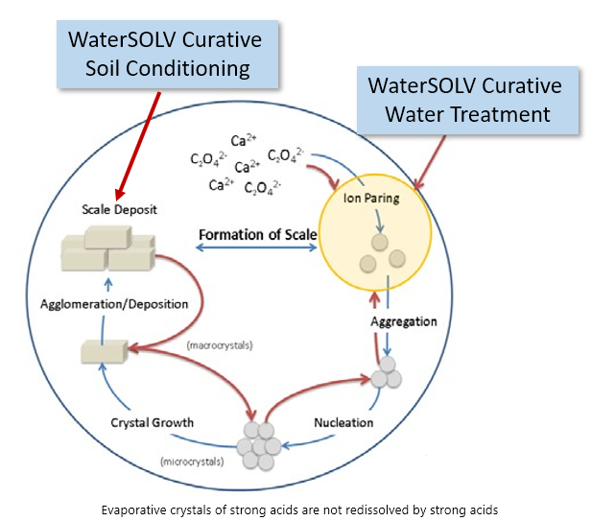

Figure 3 – The Natural Formation of Scale – Evaporative Salt Crystals / Hardpan / Mineral, Nutritional Saturation, the absorption of bicarbonates (i.e. calcium carbonate, etc.) and natural attraction of valence (i.e. calcium phosphate – sodium chloride, calcium chloride, etc.)

The Solubility and Insolubility of Elements

The most soluble elements are zinc, N and sodium, all interesting that they can be the most toxic as well. On the other spectrum, the least soluble elements are the essential cations, Ca, K and P. The soluble elements just need about any form of water and they can be highly available to the plant, similar to oxygen and water. Yet the minerals, the cations, other than sodium, once complexed/crystalized by complexing with bicarbonate, are virtually insoluble, unless acidified.

Here is a chart showing the solubility of calcium derivatives. Note how insoluble most all forms are other than the carbonate and acetate forms. Note how insoluble calcium sulfate is – gypsum.

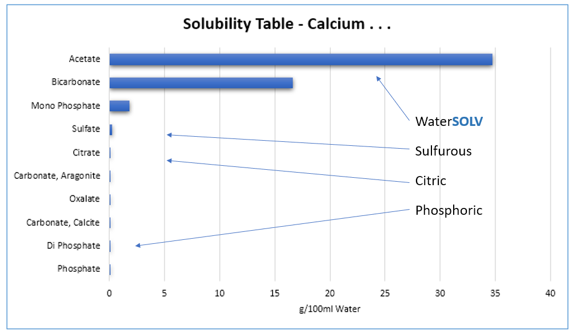

Yet as an industry, we acidify adding calcium sulfate / gypsum, with sulfuric acid, adding more sulfur that will break down to sulfate. At the same time we can watch the calcium and sulfate build up in our soils (by comparing available elements to exchangeable cations) and see water penetration become worse and worse year over year, along with what we refer to are trickle down impacts of cementation, anoxicity, harbored toxins and gasses, declining vegetation and increased costs.

We believe the benefit of rain, a good solvent, is freeing up nutrition. The facts are it frees up the N, the toxins, provides watering but the real benefit is H20 and O2 – dissolved oxygen. As the soluble water and O2 are consumed, following comes the N, then the Na, Cl and Zinc. The complexes of Ca, Mg, P and K, remain insoluble crystals Even pure distilled water does NOT dissolve complexes of scale as demonstrated in this video.

https://www.youtube.com/watch?v=PwwmTBtAuAQ&feature=emb_title.

The Detriments of pH control with Sulfurous Acids
Sulfuric, N-pHuric and Sulfur Burners
Gypsum (Calcium Sulfate)

We believe that by reducing pH we dissolve scale to a soluble form of TDS or Ec and make the nutrients available to the plant with the water they drink. This is accurate to an extent, and for a limited time – very much like a rubber band – over time the rubber band ages and loses its elasticity and breaks. IN the interim, you can stretch the rubber band so far before it reaches its capacity and it can break. The acidification of salts are the same way. Over time – usually three yours, you’ll notice a difference in soil infiltration, cementation. Hardpan, anoxicity and vegetation dread, you’ll want to figure out what is going on and the need to fix it.

Typically, you’ll be led to organic matter, various wetting agents, different acids, all leading to meager results and higher costs. The problem is compounded beginning with the increasing soil saturation of calcium and sulfate which can be identified year over year through the soil analyses of exchangeable cations. Your soils, like a filter, are plugged, restricting essential hydration and nutrition flow and plant uptake. In addition, it is likely biomatter and biofilms have taken a foothold as well.

Why your soils have become this way is identified by a study done by UC Davis – where the acidified salts in water that were not consumed, evaporate to dryness and form crystals that are not re-hydratable – similarly, yet even worse to the previous chart – The Solubility of Calcium Derivatives.

UC Davis Chemwiki study revealed the problem in the addition of a strong acids is the evaporative salts are not re-hydrated by additional acid. This leads to the cementing of your soils but technically hindering the ability to form hydratable available nutrition and propagating the hindering of toxic elements, biology and slimes.

Strong Aids Will NOT Dissolve Salts of Strong Acids

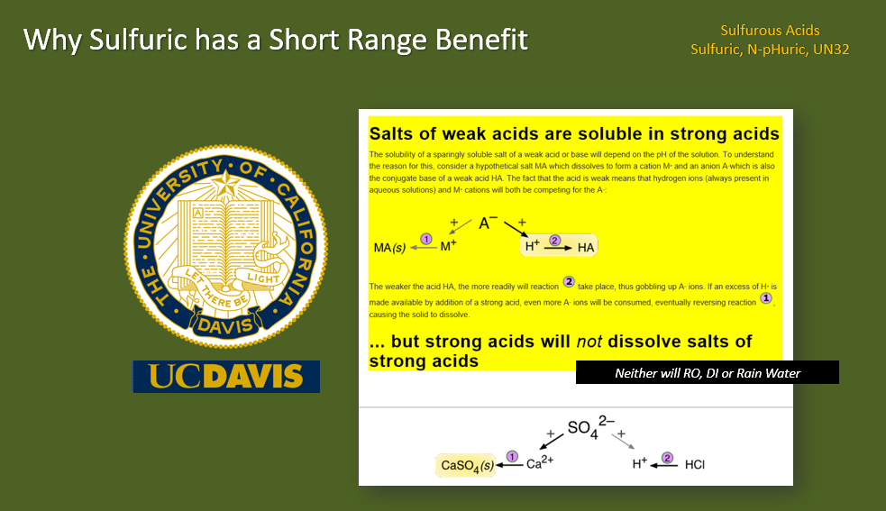

HCT and the WaterSOLV™ Solutions have overcome this dilemma through chemistry, and added the biology and chloride salts mitigating solutions as well.

Observations & Interpretations

Customer Notations:

None

Water

Hardness is 314, HCO3 290 – Treatment is 3.02 ppm Curative. Good Conditions, Beneficial.
Sodium 186 ppm, Cl 281 ppm – These are BAD conditions and have to be treated.
NO3-N 2 ppm – Great amount of sustainable N maintain good infiltration.

Water Biology

Total Bacteria Exponent 5
Water has plenty of food sources; Sulfate 166 ppm through N, Fe and Mn are negligible in the water.

Soil

No data.
Assumed extractable cations to be troublesome, chloride and sodium salts to be problematic, as well as anoxic soils from the sulfur/sulfate loading with Bac T of 5 exponents, supplemented with no rain provided much desired dissolved oxygen.

Soil Biology

Likely depleted of Dissolved Oxygen and containing anoxic conditions, especially would eb noted in low lying water collections areas.

Tissue

No data.
Subject the chloride and sodium burn along with biological restrictions from anoxic soils and bio-films.

Summary

- It is hard water, salty water, has the bacteria and the sulfur to pose lots of agronomical hardship and expense.
- These conditions can me mitigated with water treatment and soil conditions remediated over time.
- Anything receiving the treated water will be impacted.
- Soils analyses are recommended for soil remediation recommendations. We should inspect the exchangeable cations and the level of NO3-N and Na.

Water Calculations from the HCT Mobile App Reports

Water
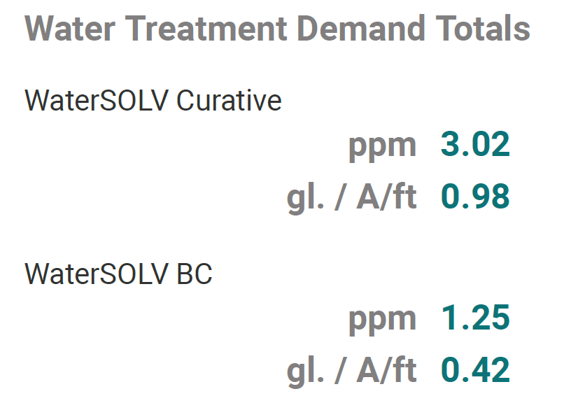

Soil Remediation

Where soils need to be remediated, with the water also being treated, if N and or Na are complexed to excessive levels, a 2x treatment rate for the first few watering’s should be applied.

It may also be necessary to adjust the watering practices from watering to flush, to watering to water. You do not want to flush salts, you want to water to maintain moisture within the soil throughout the root profile.

This is NOT a replacement for macro and micro nutritional necessities being maintained in the soil, should the soil be deficient of any of them.

Visual results are obvious by growth rate, vitality, heat stress tolerance, infiltration, overall vitality and pest resistance. Visual results are normally seen from weeks to as much as 9 months in several applications and the chemistry works its way through the soil and the vegetation.

Application Methods

Both Curative (acid, exceptionally fumy just like pool acid, corrosive to metals but not to skin) and BC (peroxide based, will oxidize skin, D A N G E R O U S to eyes), are volatile mixed together unless diluted significantly in water.

Both products are miscible with most fertilizers and become part of the water just by addition. Properly diluted, they are suitable for various modes of applications, soil spray, topical, water injection. Usually they are compatible with most adjuncts and fertilizers aiding in solubilization as well as the nutrient uptake. NOT recommended for pivots due to potential corrosion risk. Ideally inject to water the blended product or each product individually for a precise prescription. M O S T A L W A Y S the Curative is applied in the discharge side of the pump station with a proper injection quill. The BC is applied on the intake side of the pump station or at the intake of the water source but not into ponds due to undeterminable consumptions of product. While BC is not corrosive, BC itself may be injected in the suction side of water wells and upon contact it will feel like a burn until rinsed adequate with water. Where the Curative will not feel like a burn and does not attack skin yet it is a pH of zero and contains 90% vol. pool acid (muriatic acid). The sequestering properties of HCT WaterSOLV™ AG work with other acids including sulfuric if needed.

Program Cost - Chemical and Equipment

Chemical - The cost of the chemical program is actually less expensive than buying sulfuric acid and gypsum. A detailed overview of the program and technology is available online, as are what we call the Value and Benefit Offsets.

https://www.hctllc.com/value-and-offset

The return on investment is greatly and significantly in favor of the grower. Technically, everything we do and claim is verifiable and has been reproduced through the USA for several years and is substantiated in most journals relating to chemistry, biology, science, physics and agronomy.

Product Pricing:

Product Package Treatment Rate Cost/gl. Cost per million gallons of water
Curative 265 gl. Tote 3.02 ppm $40.00 gl. $120.80
BC 53 gl. drum 1.25 $65.00 gl. $ 81.25

Estimate this amount year one incorporating spoil curation
Reduce this amount 10% year two for water demand / treatment reduction

Product is delivered in single use one-way containers. 1-gallon of Curative displaces 9 gallons of sulfurous product. Therefore, you can anticipate using 10% of the volume of product you are accustomated to using if using sulfurous products.

Note: Cost per gallon x ppm use rate = cost per million gallons of water / 3.068 = cost per A/ft. of water
Competitive Use Cost Comparison: Cost per gallon x gallons per million gallons of water = Use Cost

Equipment – The equipment must be designed for acid and or peroxide. The volume of chemistry will be 1-10th of the acid volume you’ve previously used. The BC volumes is very low, typically less than 1 gallon per million gallons of water. The chemistry may be diluted with water to accommodate existing larger pump volumes. The chemistry may be mixed in adequate volume of water to facilitate just 1 pump. The Curative requires a fume scrubber (vent to a container of water), the BC does not. Every location should have an eye wash station and adequate rinse water (equipment).

Smart Acid Pump with adjustable quill $1,249.50 ea.
HCT’s Flow Switch Controller (see video) $2,988.30 ea.

Various Forms of Scale including zebra/quagga mussels

Curative can convert these scales to available nutrition. Curative and WaterSOLV™ AG (without the use of an acid) can prevent these scales from forming.

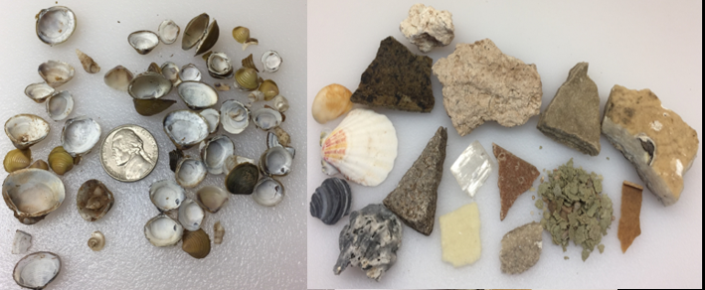
Figure 5 – Various forms of complexed nutrients.

The USDA/NCRS in 2011 Published Solubility of Elements are various pH Values. Driving pH low and adding sulfuric acid is not a sustainable solution.
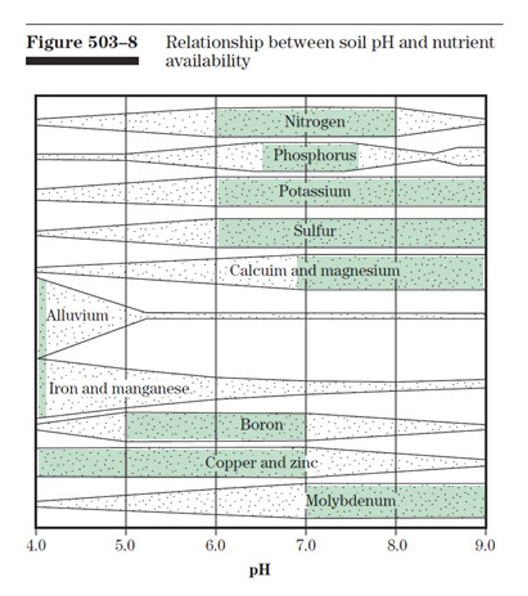
Figure 6 – pH Sweet Spots (conventional Agronomy) - USDA – NRCS – National Agronomy Manual
Section 503.8 - Relationship Between soil pH and Nutrient Availability

Comparison to Sulfurous acid and Gypsum

https://www.hctllc.com/sulfurous - Why add more calcium and sulfate, gypsum, a desiccant, when there is so much in the soil already?

Additional Information

HCT puts vast resources into testing, research and conveying information through tier website and YouTube Channel, including data, forms, results and video testimonials. We’re located at www.hctLLC.com.

Thank you for the opportunity to be of service. Please contact us if you have any questions.

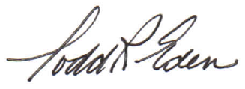
Todd R. Eden
Principal
(480) 650-6955
teden@hctllc.com

We Make Water a Better Solution
Sustainable Chemistry & Biology to Water
Well-Klean©, WaterSOLV™, Water Treatment for Agronomy™, Water pHix & WaterSOLV™
and Grow are trade names of HCT, LLC
Select products are accredited by NSF Standard 60, ANSI, Standards Council of Canada, and
the California Department of Food & Agriculture
His plan is always perfect and we choose to follow His lead.

References of Interest

- USDA – NRCS – National Agronomy Manual – February 2011 - (190–V–NAM, 4th Ed., February 2011)

  - 503.8 Relationship Between soil pH and Nutrient Availability (see Figure 6)

  - 503.31 Managing nutrient losses

  - 504.02 Crop water requirements

  - 504.03 Irrigation water and plant growth

  - 504.07 Irrigation related agricultural salt problems - Application of irrigation water

  - 508.01 Soil structure - (g) Salt-affected soils – Sodicity
Dispersion, the release of individual clay platelets from aggregates, and slaking, the breakdown of larger aggregates in smaller aggregates, lodge in soil pore spaces, reducing permeability and decreasing porosity, which leads to soil crusting and poor tilth. Adding gypsum to the soil surface or even to irrigation water can effectively avoid or even alleviate problems with reduced infiltration rate and seedling emergence (through crusted soil). A sulfur source can also be added to enhance acidification of the soil. For soils already saturated with calcium (carbonate), the addition of gypsum or sulfur is ineffective in treating sodicity. Increasing organic matter levels by continuous cropping, residue management, establishing tolerant plant species and removing excess water is more sustainable.

- Soil, Water and Plant Characteristics Important to Irrigation – North Dakota State University, December 2017

- Saturation Paste Extract - CALCIUM, MAGNESIUM, SODIUM, AND SAR - AAS or ICP-AES Method – S-1.60

- EXTRACTABLE POTASSIUM, CALCIUM, MAGNESIUM, AND SODIUM - Ammonium Acetate Method - S - 5.10

