

7032 East Cortez Road

Scottsdale, AZ 85254

(888) 788-5807

info@hctllc.com

www.hctllc.com

**Well-Klean® Solutions**

Water Well Rehabilitation

**WaterSOLV™**

Making Water a Better Solution

Well-Klean®, WaterSOLV™ Water Treatment for Agronomy, WaterSOLV™ GROW & WaterSOLV™ pHix are tradenames of HCT, LLC

Select Solutions Registered with:

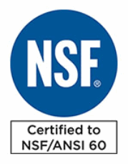



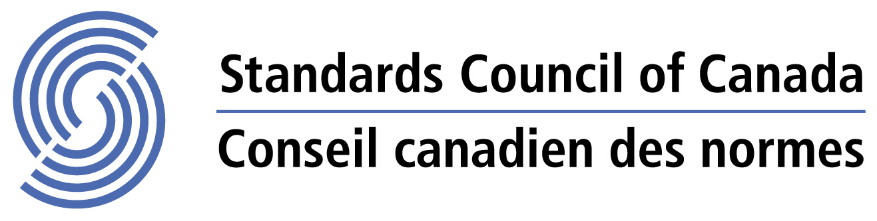

California Department of Food and Agriculture

January 7, 2021

Subject:

HCT Recommendations

,

We’re always grateful for all that goes into helping a grower realize a higher return on their work and investments. That goes to say also if we knew it was questionable whether we could have a positive impact or not, we’re fortunate to be able to say so.

In this case the timing was good as explained previously. We’ve attached data for the water and soil with the interpretations and recommendations.

The plan we’ve recommending to change involved perhaps the most practical approach of ripping soil, topically applying various nutrients and some biology. The plan we propose is reversing what caused the cementation and crop stresses, utilizing water treatment, soil remediation via water treatment, along with management of biology, addition of dissolved oxygen and mitigating the toxic effects of chloride salts including sodium – all through wter treatment and maintaining adequate nutrients as they are consumed from the soil with the use of the program. The consumption would likely be over quite a period of time, with the exception to NO3-N.

It was also noted that they must STOP using copper sulfate, sulfur and sulfate products in the pond water and addition to soils. There would also be no need for any addition of gypsum or ripping of the soils, nor leaching the soil salts by flushing them with water. Technically, the water is adding loads of sulfur and it is not capable of leaching the accumulated salts in this soil.

They will want to You’ll likely want to do a 2x treatment rate for the first 3-4 watering’s as well as be sure to adequately water, but do not water to flush – water to water. They’ll see the results over 60-90 days coming through if they haven’t already experienced it somewhere else.

Thank you for the opportunity to be of service.



Todd R. Eden

Principal

(480) 650-6955

[teden@hctllc.com](mailto:teden@hctllc.com)

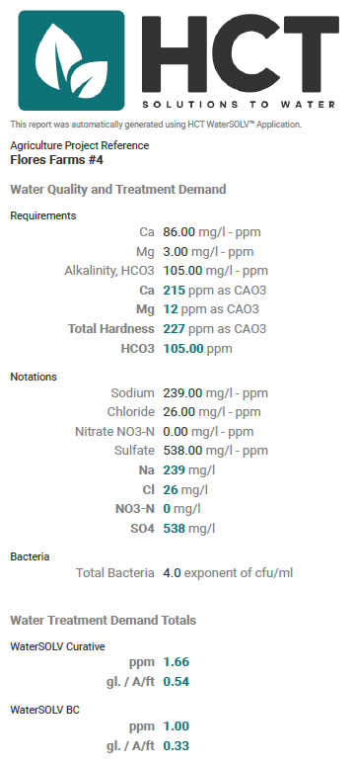

Hardness treated is nutrition. Sulfate with Bacteria is biologically problematic. Chloride salts and sodium is toxicity. Keep in mind this is the water supply and WaterSOLV™ Curative and BC mitigate these water properties.

**Soil Data**

Averaged at 3 to 4’

Note: Data is by Method SP3, however K is by Ammonium Acetate. Not metals or sulfur reported. Serious sodium chloride issues, likely accompanied with chlorides of calcium, iron and zinc.



**Tissue Data**

Acetic Acid Extract

Boron extremely high. Highest we’ve ever seen and it’s with Zn and Iron but not necessarily calcium (chloride salts). Cu and Mn elevated. Al not reported, Cations (other than Na) are deficient.

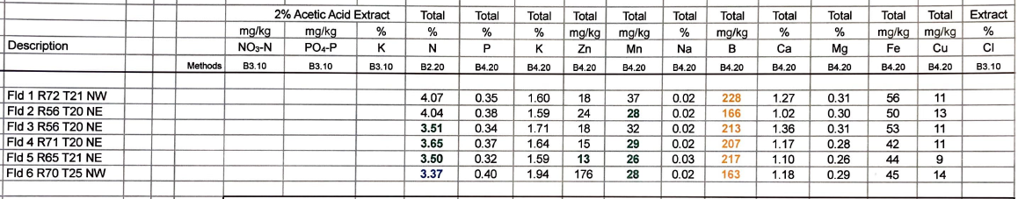

**Soil Data II** – 12/08/2020

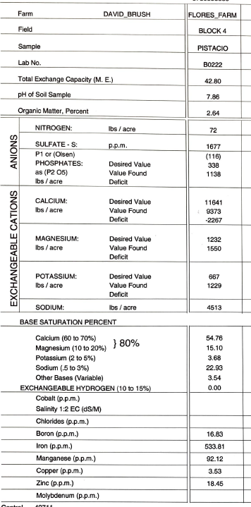

**Soil Data**

Incorporating other data from 12/8/2020



**Interpretations**

1. Moving forward, you should try to get water and soil data in a uniform manner. Water by mg/L. Soil by both SPe of treated water in mg/L, also Cation Exchange capacity by AA in mg/l. This data can then be easily logged, trended and managed with clarity.
2. It’s clear to see the soils are saturated, cemented, loaded with complexed salts of nutrition and water hardness, but also of food sources for bacteria, where the bacteria is at an exponent of 4 which is bad, and the food sources of both water and soil are abundant. With adequate water and desired but unobtained infiltration in this case the bacteria can setup at root intakes and hinder nutrition uptake while generating and releasing toxins of H2S and H2SO4 directly into the root uptake. The bacteria can also form polysaccharides and block the flow of about everything including water, acid, N as well as oxygen.
3. ALSO extremely toxic soils of chloride salts, notable by the chloride and sodium levels. This will encompass calcium, iron and zinc chloride as well as carry Boron through by valence bonds.
4. While rain, and the lack of this season of 2020, will bring pure H2O and dissolved oxygen 1) it will NOT break down the bound nutrients and it will solubilize the chloride salts of sodium, zinc and boron to damage the trees and hinder production following the utilization of the water, oxygen and NO3-N.
5. Tissue wise you can clearly see the deficiency of the beneficial cations and excess of the detrimental salts namely manganese and boron toxicity being sustained with N that can hinder oxygen flow and again vegetation vitality.

**Recommendations**

1. Both Curative and BC are required. As water treatment, 1.0 ppm BC and 2 ppm Curative.
2. Initial treatment should be 2X rates of BC and 4X rates of Curative – flood watering. Complete saturation.
3. 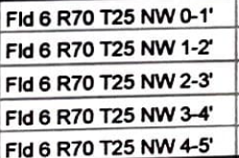This should continue until infiltration is realized visually, and supported by moisture retention at the 24-inch depth.
4. Keep an eye on maintain adequate NO3-N levels based on replacement needs for the specific crop, however keep levels

below 10 ppm at any given time.

1. Feel welcome to take soils analyses at the levels they have been being taken (I,2,3,4,5 ft. levels).
   1. Be sure to do method SPe, mg/l with treated water and method AA exchangeable cations mg/l.
2. Maintain adequate nutritional levels in the soil based on a balance between the two soil analyses methods.

**Observations and Timing**

1. Technically you will observe the increase of salts in the analyses as they are broken down to an available form, as you see when comparing SPe versus AA levels of the salts in the soil.
2. You will see pH suppression. It will be maintained to under 8.0 with adequate and sufficient product added.
3. You’ll see Ca, Fe and Al move through the plants and tissues resulting in healthy color and increased leaf size (about double).
4. Eventually water penetration throughout the soil profile.
5. From infiltration, less water frequency and demand. Plants show little signs of heat stress.
6. Increased pest resistance.
7. Significant reduction in fertilizer demands.
8. The depletion of nutrients in the soil by pant uptake.

Please refer to our website for a list of all observed value and benefits. <https://www.hctllc.com/value-and-offset>

Timing - In the soil you will observe the changes occurring within 4-6 weeks. Low area where water has always accumulated will take longer as these are areas usually where biology has established more of a foothold and it takes longer to over come unless treated with more chemistry, perhaps topically. In the plant, predicated on the time of year and crop, it takes longer to move the chemistry through the crop to release the bound products within the crop. In some of the worst water, soil and arid cases they observed it come though age-old trees at about 120 days. In general, 90 to 180 days and you’ll see the dramatic impact in vitality and leaf size.

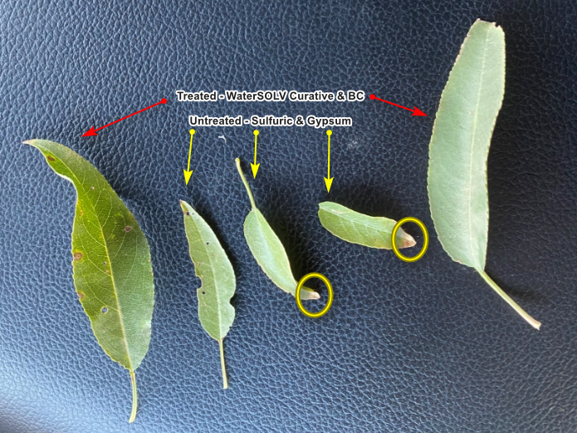



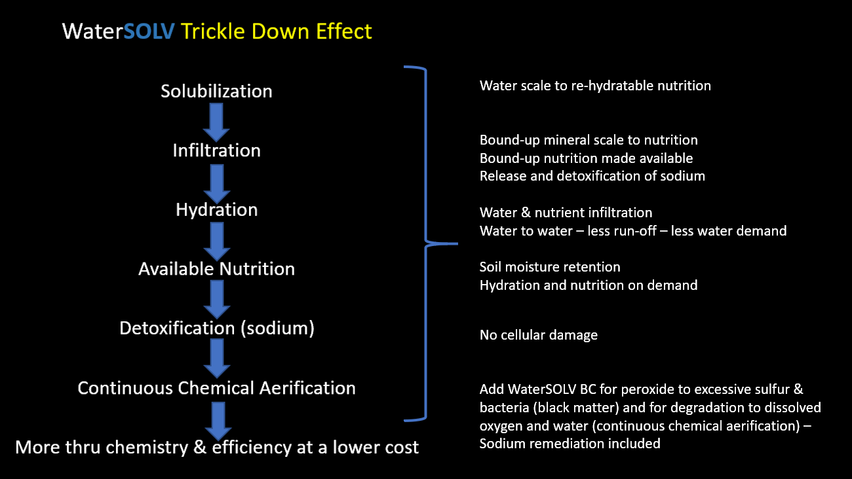

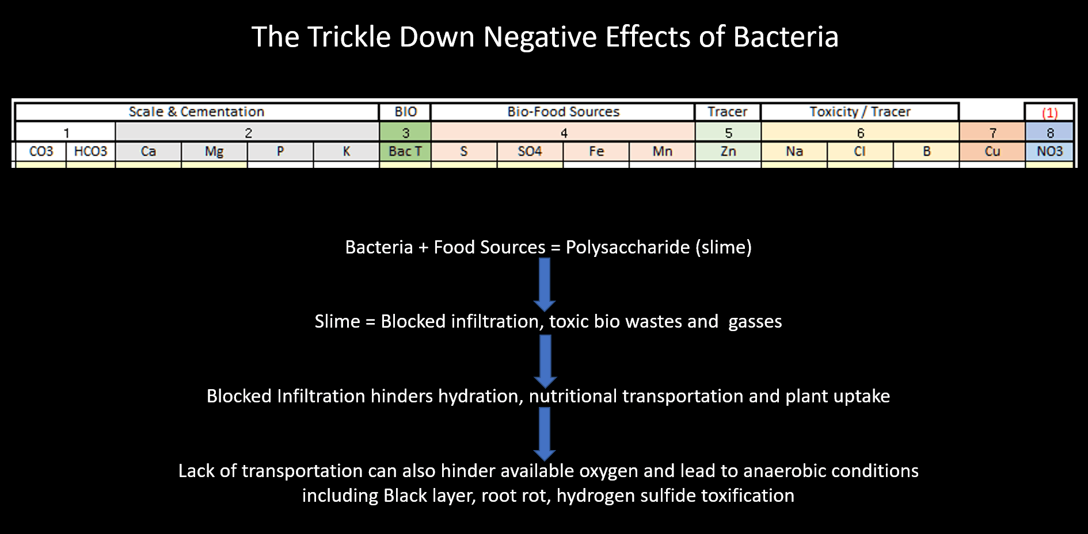



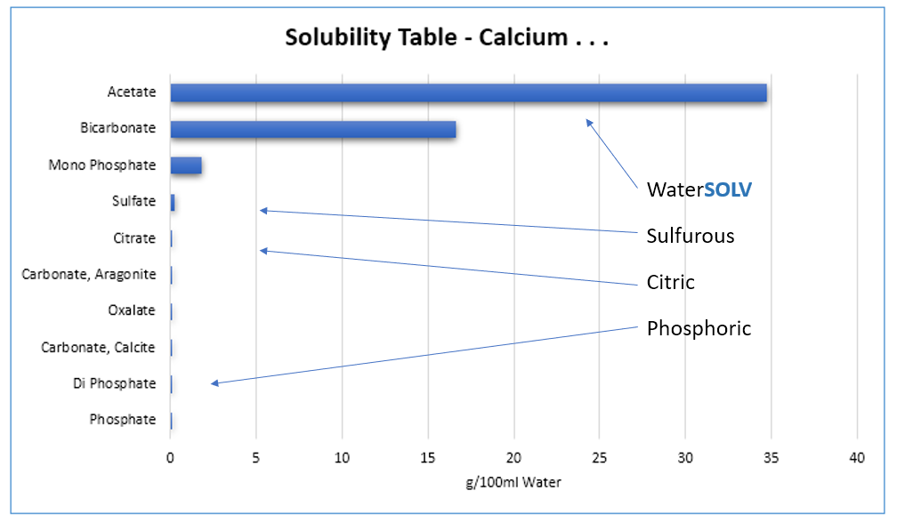

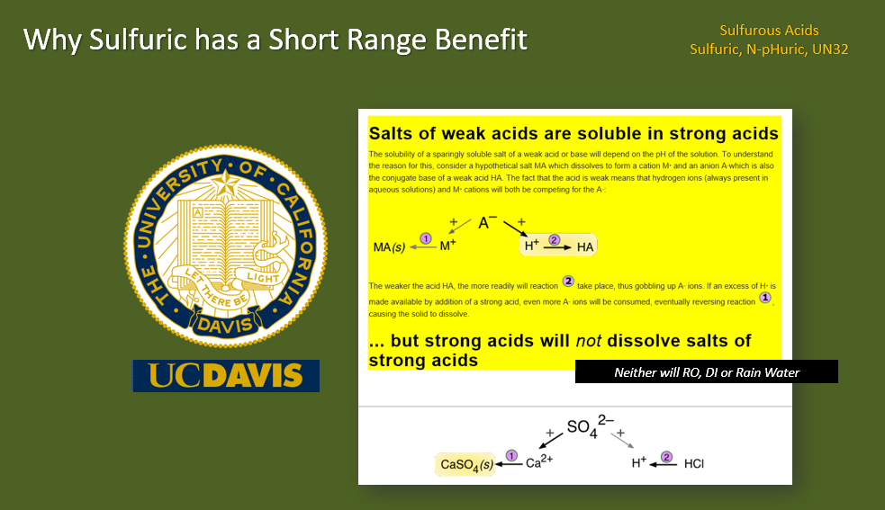

**Various Forms of Scale including zebra/quagga mussels**

HCT’s WaterSOLV™ Curative and WaterSOLV™ AG can both prevent these scales from forming through its ion exchange technology, HCT’s WaterSOLV™ Curatives can gradually dissolve them back into soluble nutrition.

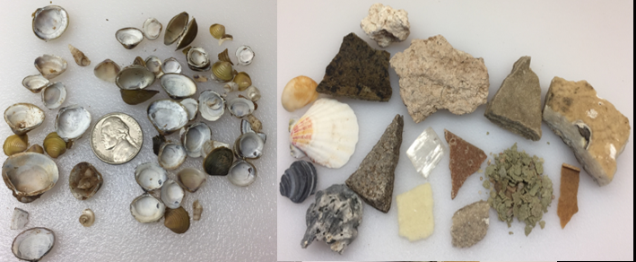

Figure 1 – All forms of complexed nutrients.

USDA/NCRS – Solubility of Elements are various pH Values

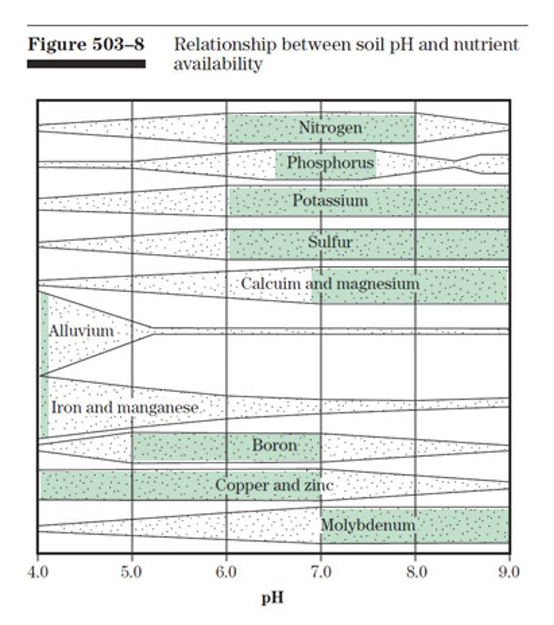

Figure 2 – pH Sweet Spots (conventional Agronomy) - USDA – NRCS – National Agronomy Manual

Section 503.8 - Relationship Between soil pH and Nutrient Availability

**References of Interest**

1. USDA – NRCS – National Agronomy Manual – February 2011 - (190–V–NAM, 4th Ed., February 2011)
   1. 503.8 Relationship Between soil pH and Nutrient Availability (see Figure 6)
   2. 503.31 Managing nutrient losses
   3. 504.02 Crop water requirements
   4. 504.03 Irrigation water and plant growth
   5. 504.07 Irrigation related agricultural salt problems - Application of irrigation water
   6. 508.01 Soil structure - (g) Salt-affected soils – Sodicity

Dispersion, the release of individual clay platelets from aggregates, and slaking, the breakdown of larger aggregates in smaller aggregates, lodge in soil pore spaces, reducing permeability and decreasing porosity, which leads to soil crusting and poor tilth. Adding gypsum to the soil surface or even to irrigation water can effectively avoid or even alleviate problems with reduced infiltration rate and seedling emergence (through crusted soil). A sulfur source can also be added to enhance acidification of the soil. For soils already saturated with calcium (carbonate), the addition of gypsum or sulfur is ineffective in treating sodicity. Increasing organic matter levels by continuous cropping, residue management, establishing tolerant plant species and removing excess water is more sustainable.

1. Soil, Water and Plant Characteristics Important to Irrigation – North Dakota State University, December 2017
2. Saturation Paste Extract - CALCIUM, MAGNESIUM, SODIUM, AND SAR - AAS or ICP-AES Method – S-1.60
3. EXTRACTABLE POTASSIUM, CALCIUM, MAGNESIUM, AND SODIUM - Ammonium Acetate Method - S - 5.10